

École Centrale Lyon

Combustion

Report

**Numerical Analysis of Turbulent Flame**

**Students : - REYYA** Harish

**Professor in charge : -** GIAUQUE Alexis

**2022-2023**

TABLE OF CONTENTS

**1 Introduction3**

**2 Part 1: Numerical Set Up and Preliminary analysis4**

2.1 Numerical Set Up4

2.2 Preliminary Analysis5

**3 Part 2: Analysis of the effect of the local flame Extinction8**

**4 Part 3: Ways to improve the results10**

**5 Conclusion10**

1. **Introduction**

The objective of the numerical analysis used in this study was to track the behavior and characteristics of premixed flames in a moderate combustion chamber. Since whirling causes some turbulence in the flame, it is also investigated to better understand how important it is for maintaining the flame front and increasing temperature. The topology of a premixed turbulent CH4 flame is therefore examined in this numerical study as a function of the intake swirl number (S) from the inlet using the c-equation model's reaction progress variable. The no-slip condition is assumed, the chamber walls are assumed to be adiabatic, and the heat fluxes are omitted.

The premixed flame's thermodynamic characteristics, including flame temperature, have a tendency to linearize along the combustion chamber in the model. Additionally, the investigation of how to maintain this value for various whirling numbers and premixed velocities and the maximum rate of the flame's stretching strain factor before self-extinction. This value is crucial for understanding the features of combustion chambers since it indicates when the flame first appears and the circumstances under which it can continue to burn without extinguishing.

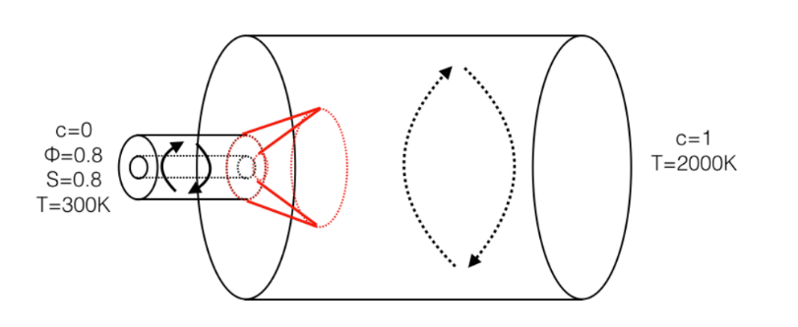

Figure.1 Geometry set-up

Figure 1 shows that c is zero at the inlet, where there is an unburned mixed fuel at 300K, and one at the outflow, where there is a greater surface area, assuming a fully burned mixture at 2000K. This demonstrates that for an adiabatic flame temperature given as; there is a linear increase along the chamber.

**2. Part 1:** Numerical Set Up and Preliminary analysis

**2.1 Numerical Set Up**

The following thermodynamic quantities must be used to build up the provided mesh of a modern combustion chamber numerically.

* Inlet axial velocity of 50m/s
* Since the flame is turbulent, an inlet turbulence intensity of 5
* Laminar flame speed measured at 0.25m/s
* An azimuthal velocity of 40 m/s
* Adiabatic flame temperature at the end of combustion 2000K
* Characteristic turbulence length LT = 0.01m

Fluent loads the mesh, and the setup steps are summarized below:

1. We begin by setting the Model to be utilized from the setup, general tab in Fluent. As directed, set it to k-Ꜫ and choose viscous. Next comes species and ideal premixed combustion, followed by adiabatic and the c-equation model. We have a turbulent flame, so the turbulent flame speed model is set to the default constants for the *Zimont* model.
2. Second, we set the material properties from the general tab. liquid, then air. The simulation is programmed to use a single fluid with a unit stoichiometry ratio depending on the *laminar flame speed* because this premixed model is flawless. Then we set the *critical strain rate*, which has a maximum default value of 1x108/s, together with the density, temperature, viscosity, and no slip conditions are its default settings.
3. The *inlet velocity* is first set before moving on to the boundary conditions. The 3D cylindrical velocity components are Vr = 0, Vx = 50 m/s, and V = 40 m/s for the tangential (azimuthal) component. The *Swirl Number* at the inlet, which equals 0.7, is related to V by the following: , So, S increases as the imposed azimuthal velocity increases. Then, the inlet's turbulence properties are I = 0.05 and LT = 0.01m. Finally, we set c = 0 in the species tab.

Due to insufficient total pressure, turbulence specification of I = 0.5 ten times higher than inlet, and backflow turbulent viscosity ratio of 10, we set a backflow direction normal to the boundary at the exit. The species tab is where we put c = 1 last.

1. The other tabs are configured to default. We use the typical way to initialize from the intake on the solution tab and run the simulation for at least 2000 iterations to reach convergence.

Notice that we only had one species for the current study, and we assume that the flow is steady-state equilibrium.

There is also no source term.

After establishing theses assumptions, the formula computed by FLUENT to quantify the reaction progress distribution were reduced to:

(1-1)

Where :

For one species reactant case,

(1-2)

Where :

**2.2 Preliminary analysis**

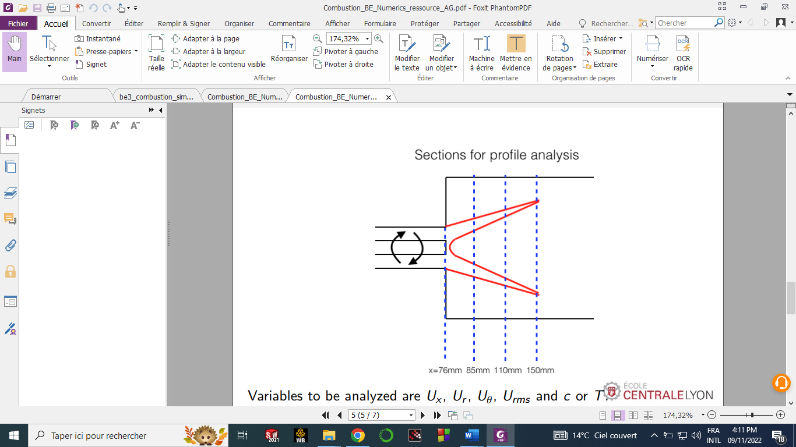

Figure.1-1 Section analysed on x-y plane

The Figure.1-1 show the local analysis where results will be plotted for this study.

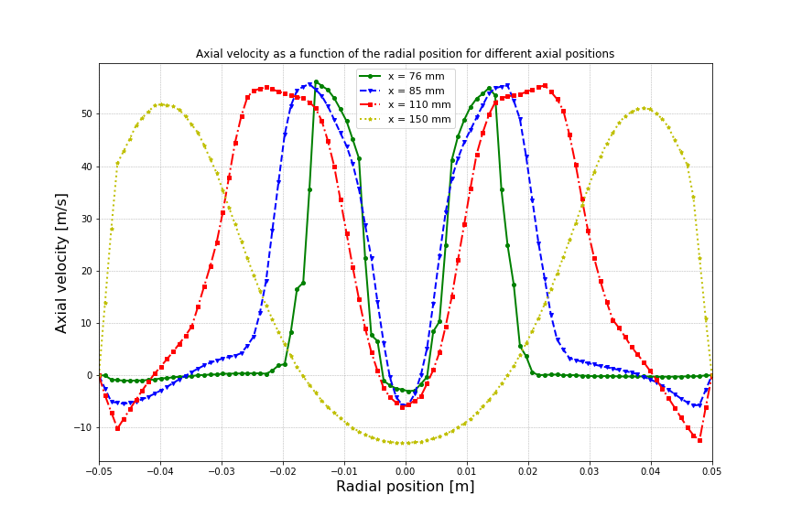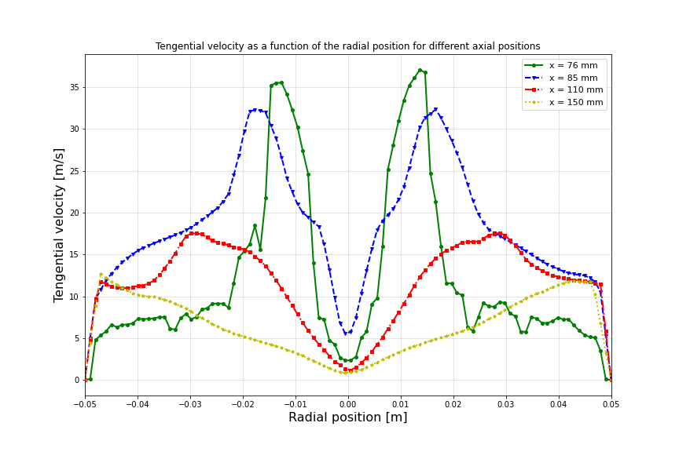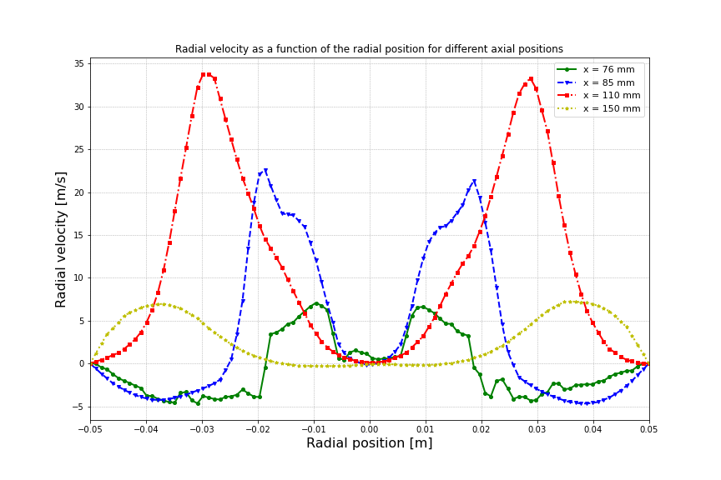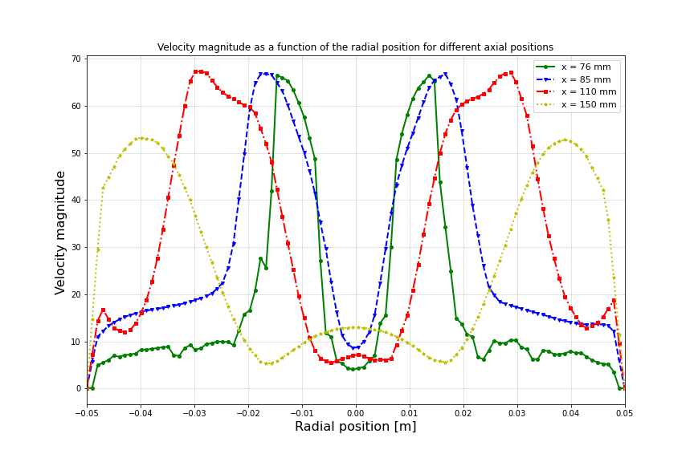

Figure.1-2 Velocity profiles at different radial positions (up-left : Axial velocity; up-right: Tengential velocity; down-left: Radial velocity; down-right: Velocity magnitude)

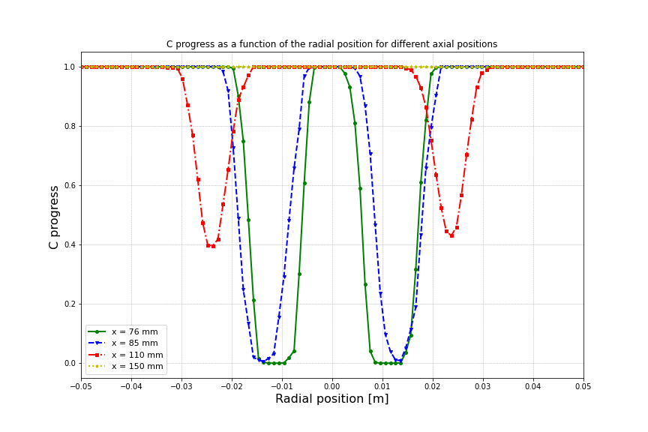  
Figure.1-3 Reaction variable progress along radial lines at different axial position (x = 76 mm; x = 85 mm, x =110 mm, x = 150 mm)

In Figure. 1-2 we see the velocity profiles into the components of cylindrical coordinates (axial, radial and tangential) then the root mean square of theses. There is an axial reverse flow in the middle of the section.

We see in Figure.1-3 that reaction rate is closer than fully burned when moving away from inlet section.

We see also that gas is fully burned for all the 4 positions in sides and the middle of the section.

This is caused by both effect of flame stretching that allow it propagation and turbulence effect that enhance mixing.

The swirl effect causes adverse pression gradient in the radial center of the geometry, then stretch. For this reason, we notice that the c progress variable is equal to one in the four measure lines there.

It causes also centrifugal force; this is the reason why we notice that the combustion progress is equal to one in the sides of the sections considered.

The flame stability can be interpreted as the thickness of curve variation (values between 0 and 1), because for absolutely stable flame, the curve can show only two values, 0 and 1. And the intermediate values are statistical time of looking burned gas or no in these positions.

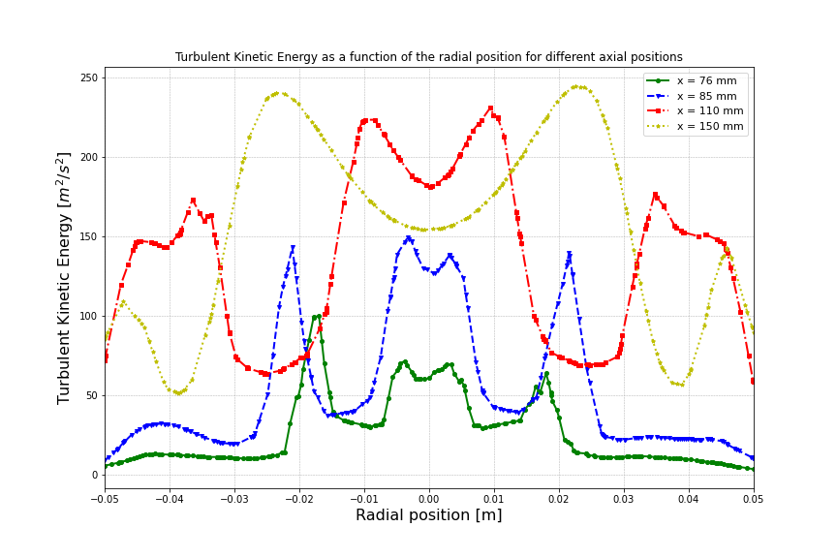

Figure.1-4 Turbulent kinetic energy along radial lines at different axial position (x = 76 mm; x = 85 mm, x =110 mm, x = 150 mm)

Figure.1-4 confirm the influence of turbulence to enhance combustion, we see that regions with high turbulent kinetic energy burns more than where it is weak.

**3. PART 2**: Effect of critical rate of stain to flame extinction

For this part we replace the critical rate of strain by 20000 s-1, that is the real value of methane/air flame. And compare the result with the results obtained in the 1st PART.

The focus will be to the combustion variable progress, because it allows to show the flame stability and it is the main objective for the present mofication.

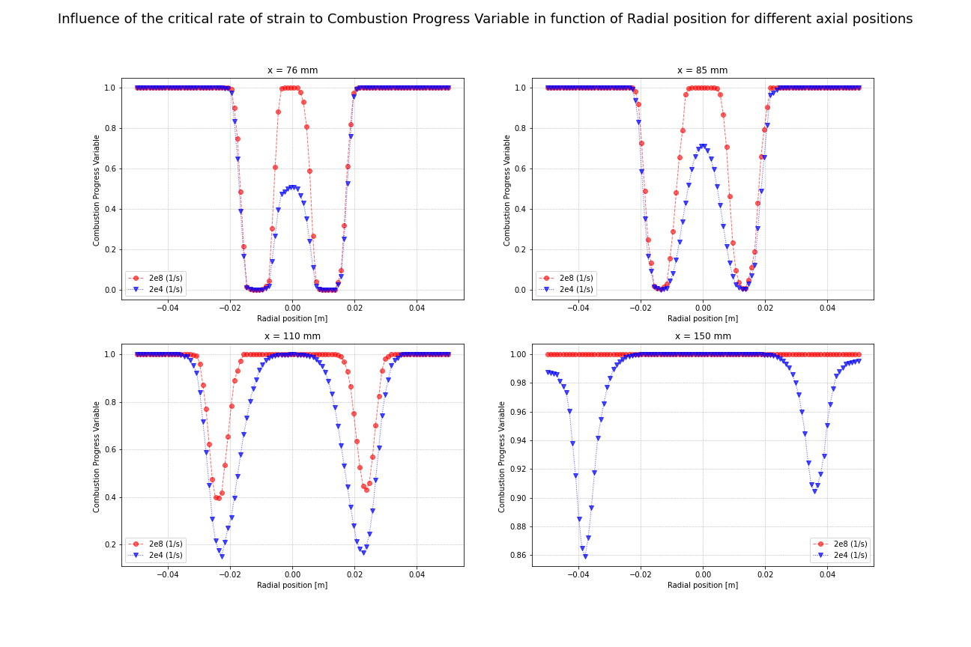

Figure.2-1 Reaction variable progress along radial lines for two critical rate of strain at different axial positions(x = 76 mm; x = 85 mm, x =110 mm, x = 150 mm)

We see in the Figure.2-1 that the effect of critical rate of strain put out the flame in some positions, and reduce the burned gas regions.

The flame is less extended for the 2nd case than the 1st, we seen that for x = 150 mm, where the region was fully burned in the 1st case, it has some unburned zones caused by extinction due to high stretch.

We can also notice that for this case, the flame is less stable than the 1st case, because of the thickness of intermediate values.

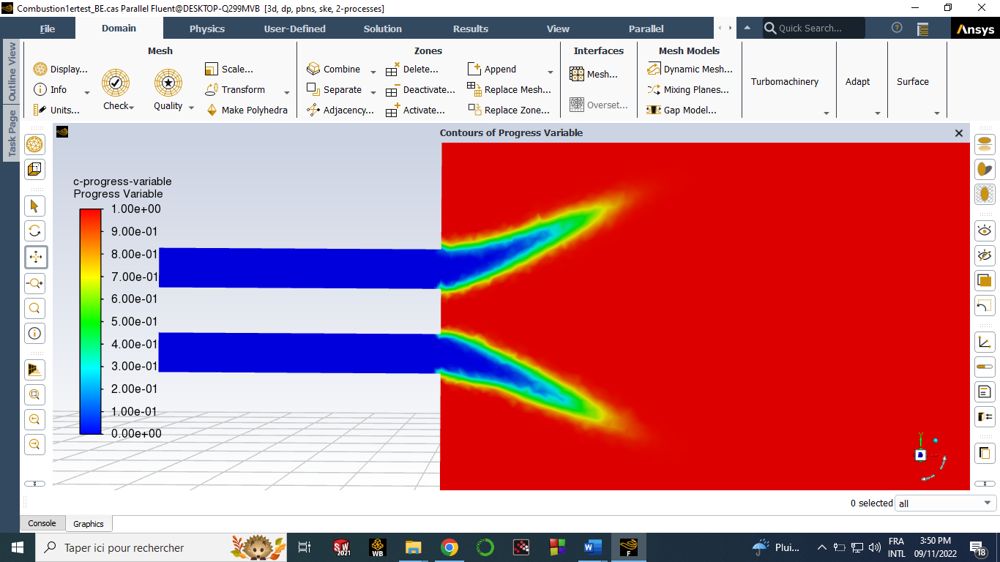

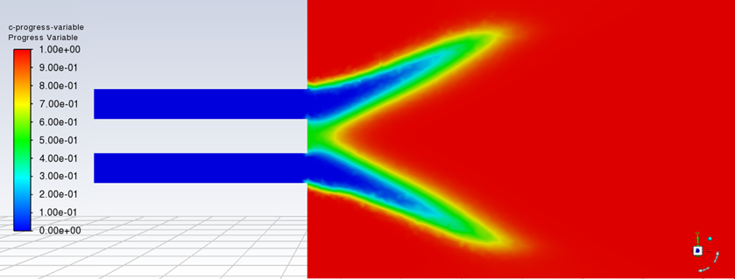

Figure.2-2 Combustion progress distribution for respectively case 1 above and case 2 bellow on axial symmetric plane.

Figure 2-2 show more clearly the extinction zone above 76 mm from the inlet. Then we can see that the reduction of the burned area and the growth of the zone of instability of flame (when c is intermediate between 0 and 1) in the case 2 compared to the case 1 results.

We conclude that critical rate of strain affects stability of flame on which depend it keep it remain burning.

**4. Part 3: Ways to improve the results**

From the part 2, we notice clearly that the behavior of flame and combustion is far from what is it in reality.

This is due to the assumption established to simplify the problem. But we see that some parameters have to be considered because they influence consequently the physics of the results.

The problem that arises is that combustion depends on a multitude of parameters, some of which are still complex to model to this day.

For this, we must be careful in the choice of which parameters we considered to optimize the computing time with the kind of results and the rate of precision needed.

Some ways to improve the results:

* Considering the Air/Fuel ratio and them chemical components to close to real combustion behavior and see the exhaust species. For pollute reduction and analysis, this consideration has to be precise and for modern investigations, it is coupled with data with machine learning methods.
* Deal with heat transfer if the aim consider and exhaust temperature like for thermal engine.
* Use non-premixed combustion, to enhance precision of results.

Due to the fact that the walls of the actual chamber are heated and require a cooling jet, the phenomena of adiabatic walls is rare. Since temperature varies in the real world in an adiabatical manner and is not stationary, the linearity of temperature evolution is another drawback for this model. In the actual world, it is difficult to manage the critical strain rate value since it also depends on the shape of the combustion chamber and the acoustic impacts of the flame and the wall, which make the flame more unstable. Therefore, it would be preferable to more or less integrate acoustic impacts in this element.

**5. Conclusion**

In this BE, we investigated doing the first fluid simulation of the combustion chamber injector of the upcoming SNECFRAN engine. Obtaining a stationary, stable solution to the problem was our main objective, and we have demonstrated that it is possible to do so, at least when employing the given models. We checked that our problem was correctly setup for the initial calculations in the first section.

After that, we examined the consequences of the local extinction of the flame caused by stretching by determining if stationary solutions could be found for various values of the strain rate. Finally, we suggested methods to enhance the simulation and the outcomes based on our knowledge and our experience with Fluent.